
2137 Roosevelt Avenue
Racine, WI 53406 www.windowwellsupply.com info@windowwellsupply.com 262.633.3707
BullWell Window Well
Installation Instructions
Steel Window Wells
End User Notes:
- Call 811 before you start digging to avoid accidental damaging of any underground Read the instructions completely before installing the well.
service lines.
- Check with your building inspector for local code requirements.
Anchor | Size | Masonry Drill Bit | Socket-  Nut Driver
Sleeve-bolt | ø3/8” x 1-7/8” | ø3/8” x 4” | 9/16
Wedge-bolt | ø3/8” x 2-3/4” | ø3/8” x 4” | 9/16
Tapcon® Screw | ø1/4” x 2-3/4” | ø3/16” x 4-1/2” | 5/16
Tapcon® Screw | ø5/16” x 2-3/4” | ø1/4” x 4-1/2” | 5/16
Materials & Tools Needed:
Warning: Use protective eyewear
- Hammer drill
- Socket or Nut Driver
- Masonry Anchors & Drill Bit
- Marker
- Silicon Caulk
- Safety Glasses
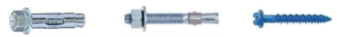
- Level
- Hardware (see table A)
Tapcon® Screws Hex Head-
Sleeve Anchor 3/8"x 1-7/8" Wedge Anchor 3/8” x 2-3/4”
washer 1/4"x 2-3/4" OR 5/16"x 2-3/4"
IRC Code:
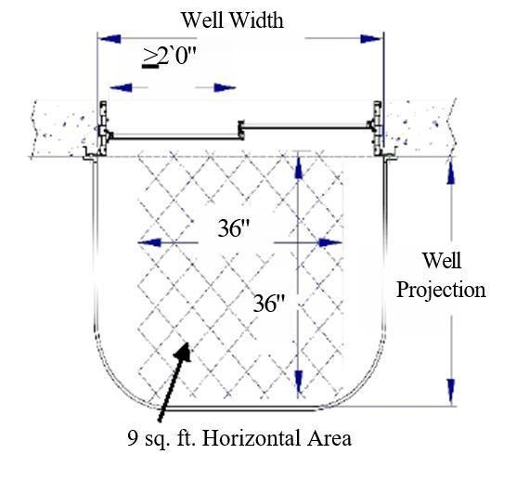
- To meet Egress the horizontal area of the window well shall be not less than 9 square feet (0.9 m²), with a horizontal projection and width of not less than 36 inches (0.91 m). The area of the window well shall allow the emergency escape and rescue opening to be fully opened. Use a Monarch Well with a minimum Width of 49" and a minimum
Projection of 36" or larger to meet egress.
- Window wells with a vertical depth greater than 44 inches (1.1m) shall be equipped with
a permanently affixed ladder. The Monarch ladders meet the IRC Code. Digging the Hole:
- Dig a hole deep and large enough for the window well and a work area.
- The window well should be centered on the window opening.
- The top of the window well top should be approx. 3" above the finished grade.
- Install the top of the well at the same height or higher than the top of the window
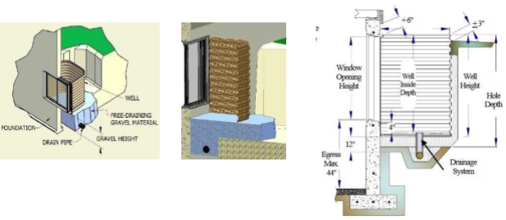
and a minimum of 6" down from the house siding. (Allowing for a Monarch THC cover installation).
- Excavate a trench for a drainage pipe from the base of the window well out to “daylight” or connect in to perimeter drain system using a 4” or larger perforated drain pipe with a perforated cap.
- Use approx. 3 yards of free-draining gravel or 3/8” pea-stone.
- Fill the hole with 12” deep clean pea gravel and level it to the baes of the window well.
- Make sure the foundation wall and window frame are clean and free of debris.
- Fill the inside window well with gravel, minimum 4” below the bottom of the window.
Well Installation – Anodic Window Well Corrosion:
- In some areas of the country, AW-IsolatorTM needs to be installed to prevent Anodic Window Well Corrosion.
- The special designed AW-IsolatorTM fits into the key-hole slots and separate the mounting screws from the steel well.
- The AW-IsolatorTM require ¼” size mounting screws and steel fender-washers to transfer the load.
- Use TapCon screws
- Typical installation requires two (2) anchors to close the top and one (1) anchor at least every 12” down each side.
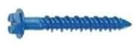
• 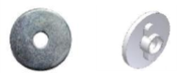
Well Height | Qty. AW-Isolator | Fender Washer AW-Isolator™  1/4" x 1-1/4"  Mounting to a Basement Wall:
36" | 8
48" | 10 | - Measure and mark the center  - The window well should be ce opening.
60" | 12
72" | 14
Tapcon® Screws Hex
Head-washer
of the window.
ntered on the window
- Mark evenly a vertical line on each side of the
window at the window well bolt holes centerline. (Width + 2")
- Mark the top holes on each side
- Use two (2) anchors close to the top and one (1) anchor at least every 12 in. down on each side. o For Concrete foundation
▪ Drill 3/8" holes and use 3/8" x 2-3/4" (washer 3/8")
Wedge Anchors, placing two (2) anchors on each side at the top and one (1) anchor at least every 12 in. down the side.
OR
▪ Use 5/16" x 2-3/4" Tapcon® w/Fender washers, placing two
(2) anchors on each side at the top and one (1) anchor at least every 12 in. down the side.
o For Block foundation
▪ Drill 3/8" holes and using 3/8" x 1-7/16" (Nut & washer size 5/16") Sleeve Anchors placing minimum of four (4) on each side, starting at the top and one (1) anchor at least every 12 in. down the side.
Mounting to a Window Frame:
- Loosen the top screws just far enough to help locate the well on the key holes of the well. Insert the removed screws with a 1/4" fender washer and loose tighten. Remove the two top screws and mount with fender washers Do not over tighten the screws.
- Concrete screws, diameter & length ± 2", recommended anchor.
- Always use fender washers on the bolts to evenly distribute the load on the window well flange!
Backfilling the Well:
- Seal the inside and outside of the well flanges to the foundation wall with silicon caulk.
- The load carrying capacity of the wells depends upon backfilling by hand or using equipment.
- Always support wells on the inside during the backfill procedure to prevent them from deforming. Consider using a knee brace.
- Use free-draining gravel or 3/8" pea-stone.
- Fill the bottom of the window well and stay at least 4 inches below the bottom of the window.
- Backfill the outside of the well slowly and evenly to prevent damage to the well. Fill within 6 inches from the final grade.
- Lastly, use clean top soil to backfill and stay 3 inches below the top of the well. Warning: Do not use frozen dirt or large rocks!
- The finished grade should slope away from the building so that water will not drain towards the window well.

